Image resampling assignment

Original image

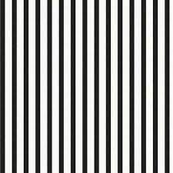

After resampling

**1. nearest neighbor method**

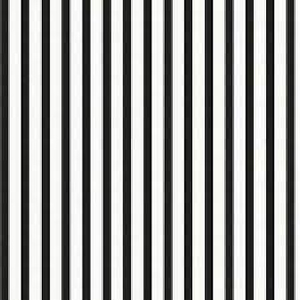

Pixels are more appeared in nearest neighbor resampling results

**2. interpolation**

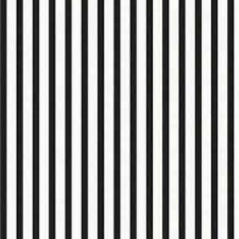

Interpolation give a much smoother and more continuous transition between pixels.